

**MVPS’s**

**RAJARSHI SHAHU MAHARAJ POLYTECHNIC,**

**NASIK**

**COMPUTER TECHNOLOGY DEPARTMENT.**

**ACADEMIC YEAR 2020-21**

**DIGITAL TECHNIQUES(22320)**

MICRO-PROJECT

ON

**“ Study about basic Logic Gates ”**

SUBMITTED BY

|  |  |  |  |
| --- | --- | --- | --- |
| **SR. NO** | **ENROLLMENT NO** | **Roll NO** | **STUDENT NAME** |
| 1 | 1910020362 | 45 | Savant Omkar Vitthal |
| 2 |  | 43 | Raut Atharva Satish |
| 3 |  | 1 | Wani Pushpak Shrikant |

**INDEX**

1. Abstract…………………….……………………………………………………….2

2.Introduction……………….………………………………………………………....3

3. History………………….…………………………………………………………...9

4. Applications……..…………………………………………………………………..10

5. Conclusion……………..……………………………………………………………11

6. Reference….…………………………………………………………………………12

**Abstract**

This paper is scrutinizes the use of different logic gates used in Digital Techniques which enables viewer to get the complete concept of different aspects of Digital Techniques. To satisfy this we have created a chart and a report signifying the use of a simple logic gates used in Digital Techniques.

**Introduction**

**1.1.Logic Gate**

Logic gates are the basic building blocks of any digital system. It is an electronic circuit having one or more than one input and only one output. The relationship between the input and the output is based on a **certain logic**. Based on this, logic gates are named as AND gate, OR gate, NOT gate etc.

Logic gates are primarily implemented using diodes or transistors acting as electronic switches, but can also be constructed using vacuum tubes, electromagnetic relays (relay logic), fluidic logic, pneumatic logic, optics, molecules, or even mechanical elements. With amplification, logic gates can be cascaded in the same way that Boolean functions can be composed, allowing the construction of a physical model of all of Boolean logic, and therefore, all of the algorithms and mathematics that can be described with Boolean logic.

**1.2.Types of Logic Gates:**

1. AND Gate
2. OR Gate
3. NOT Gate
4. NAND Gate
5. NOR Gate
6. XOR Gate
7. XNOR Gate

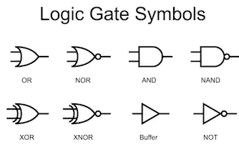

1. **AND Gate:**

A circuit which performs an AND operation is shown in figure. It has n input (n >= 2) and one output.

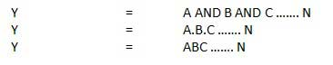

Logic diagram:

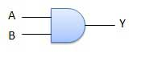

Truth Table:

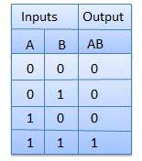

1. **OR Gate:**

A circuit which performs an OR operation is shown in figure. It has n input (n >= 2) and one output.

OR gate

Logic diagram:

OR Logical Diagram

Truth Table:

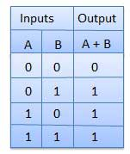

1. **NOT Gate:**

A NOT gate is also known as Inverter. It has one input A and one output Y.

NOT gate

Logic diagram:

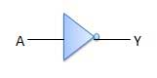

Truth Table:

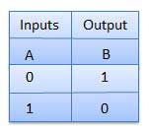

1. **NAND Gate:**

A NOT-AND operation is known as NAND operation. It has n input (n >= 2) and one output.

NAND gate

Logic diagram:

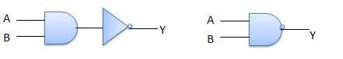

Truth Table:

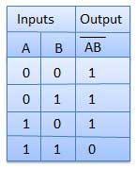

1. **NOR Gate:**

A NOT-OR operation is known as NOR operation. It has n input (n >= 2) and one output.

NOR gate

Logic diagram:

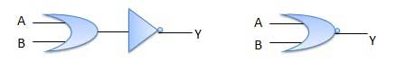

Truth Table:

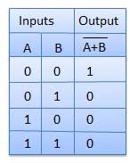

1. **XOR Gate:**

XOR or Ex-OR gate is a special type of gate. It can be used in the half adder, full adder and subtractor. The exclusive-OR gate is abbreviated as EX-OR gate or sometime as X-OR gate. It has n input (n >= 2) and one output.

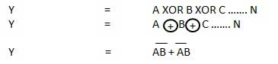

Logic diagram:

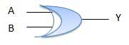

Truth Table:

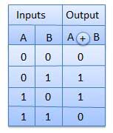

1. **XNOR Gate:**

XNOR gate is a special type of gate. It can be used in the half adder, full adder and subtractor. The exclusive-NOR gate is abbreviated as EX-NOR gate or sometime as X-NOR gate. It has n input (n >= 2) and one output.

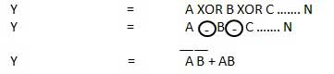

Logic diagram:

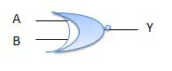

Truth Table:

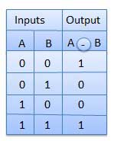

**History**

The binary number system was refined by Gottfried Wilhelm Leibniz (published in 1705), influenced by the ancient I Ching's binary system.Leibniz established that using the binary system combined the principles of arithmetic and logic.In an 1886 letter, Charles Sanders Peirce described how logical operations could be carried out by electrical switching circuits. Eventually, vacuum tubes replaced relays for logic operations. Lee De Forest's modification, in 1907, of the Fleming valve can be used as a logic gate. Ludwig Wittgenstein introduced a version of the 16-row truth table as proposition 5.101 of Tractatus Logico-Philosophicus (1921). Walther Bothe, inventor of the coincidence circuit, got part of the 1954 Nobel Prize in physics, for the first modern electronic AND gate in 1924. Konrad Zuse designed and built electromechanical logic gates for his computer Z1 (from 1935–38).From 1934 to 1936, NEC engineer Akira Nakashima introduced switching circuit theory in a series of papers showing that two-valued Boolean algebra, which he discovered independently, can describe the operation of switching circuits. His work was later cited by Claude E. Shannon, who elaborated on the use of Boolean algebra in the analysis and design of switching circuits in 1937. Using this property of electrical switches to implement logic is the fundamental concept that underlies all electronic digital computers. Switching circuit theory became the foundation of digital circuit design, as it became widely known in the electrical engineering community during and after World War II, with theoretical rigor superseding the ad hoc methods that had prevailed previously.

Metal-oxide-semiconductor (MOS) logic originates from the MOSFET (metal-oxide-semiconductor field-effect transistor), invented by Mohamed M. Atalla and Dawon Kahng at Bell Labs in 1959. They first demonstrated both PMOS logic and NMOS logic in 1960. Both types were later combined and adapted into complementary MOS (CMOS) logic by Chih-Tang Sah and Frank Wanlass at Fairchild Semiconductor in 1963.

**Applications**

The applications of basic logic gates are so many however they mostly depend on their truth tables otherwise form of operations. Basic logic gates are frequently used in circuits like a lock with push-button, the watering system automatically, burglar alarm activated through light, safety thermostat & other types of electronic devices.

The main advantage of basic logic gates is, these can be used in a different combination circuit. In addition, there is no boundary to the number of logic gates that can be utilized in a single electronic device. But, it can be limited because of the specified physical gap within the device. In digital ICs (integrated circuits) we will discover a collection of the logic gate region unit.

By using mixtures of basic logic gates, advanced operations are often performed. In theory, there’s no limit to the number of gates that may be clad along during a single device. However, in the application, there’s a limit to the number of gates that may be packed into a given physical area. Arrays of the logic gate area unit are found in digital integrated circuits (ICs). As IC technology advances, the desired physical volume for every individual gate decreases, and digital devices of an equivalent or smaller size become capable of acting with more complicated operations at ever-increasing speeds.

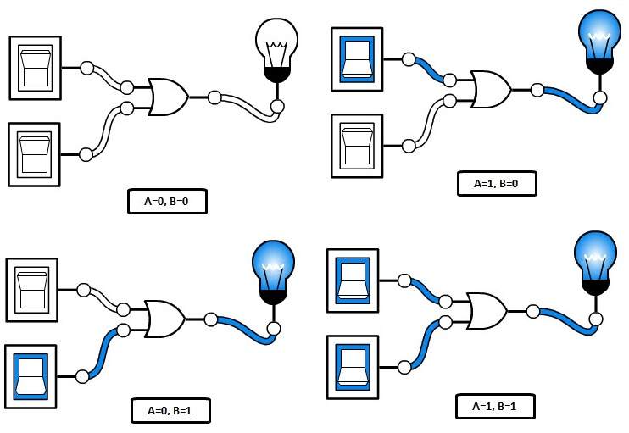

**Conclusion**

Logic circuits include such devices as multiplexers, registers, arithmetic logic units (ALUs), and computer memory, all the way up through complete microprocessors, which may contain more than 100 million gates. In modern practice, most gates are made from MOSFETs (metal–oxide–semiconductor field-effect transistors).

Compound logic gates AND-OR-Invert (AOI) and OR-AND-Invert (OAI) are often employed in circuit design because their construction using MOSFETs is simpler and more efficient than the sum of the individual gates.

The output of one gate can only drive a finite number of inputs to other gates, a number called the 'fan-out limit'. Also, there is always a delay, called the 'propagation delay', from a change in input of a gate to the corresponding change in its output. When gates are cascaded, the total propagation delay is approximately the sum of the individual delays, an effect which can become a problem in high-speed circuits. Additional delay can be caused when many inputs are connected to an output, due to the distributed capacitance of all the inputs and wiring and the finite amount of current that each output can provide.

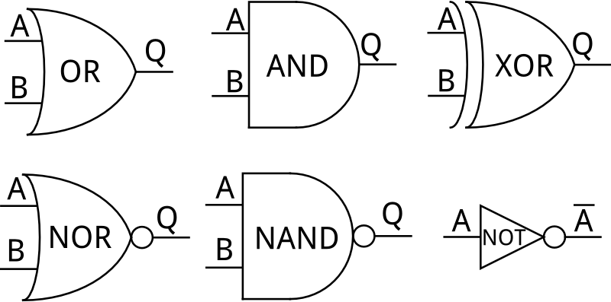

**References**

1. [www.google.com](http://www.google.com)
2. [www.tutorialspoint.com](http://www.tutorialspoint.com)
3. [www.wikipedia.org](http://www.wikipedia.org)